**Use Case analysis - sequence and collaboration diagrams**

SEGY eShopper

**Team members:**

|  |  |  |
| --- | --- | --- |
| 110995 | Eden Teclemariam | Zere |
| 611145 | Gebrehiywet Fissaha | Tsehaye |
| 611098 | Simon Abraham | Weldemichael |
| 110930 | Yohannes Baye | Mulualem |

**Date: Sunday, May 24, 2020**

# sequence diagrams

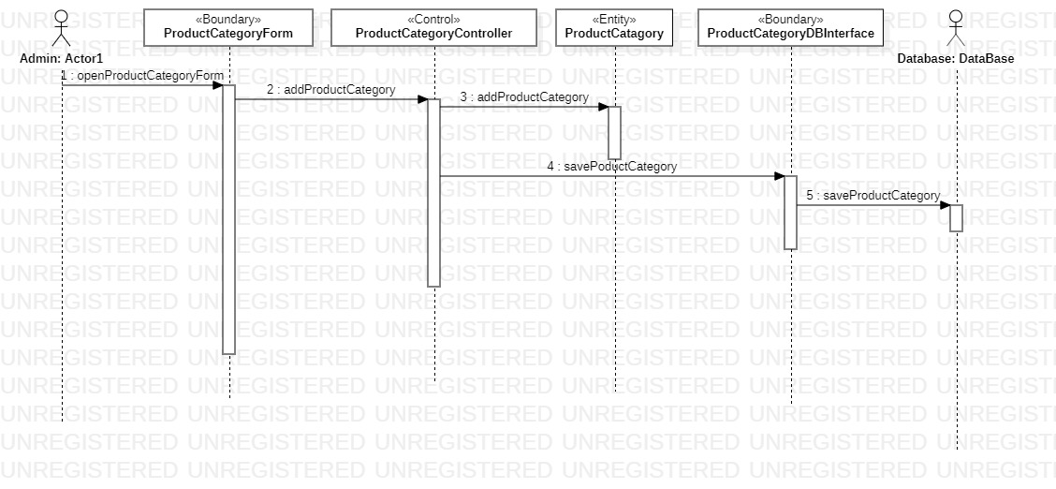

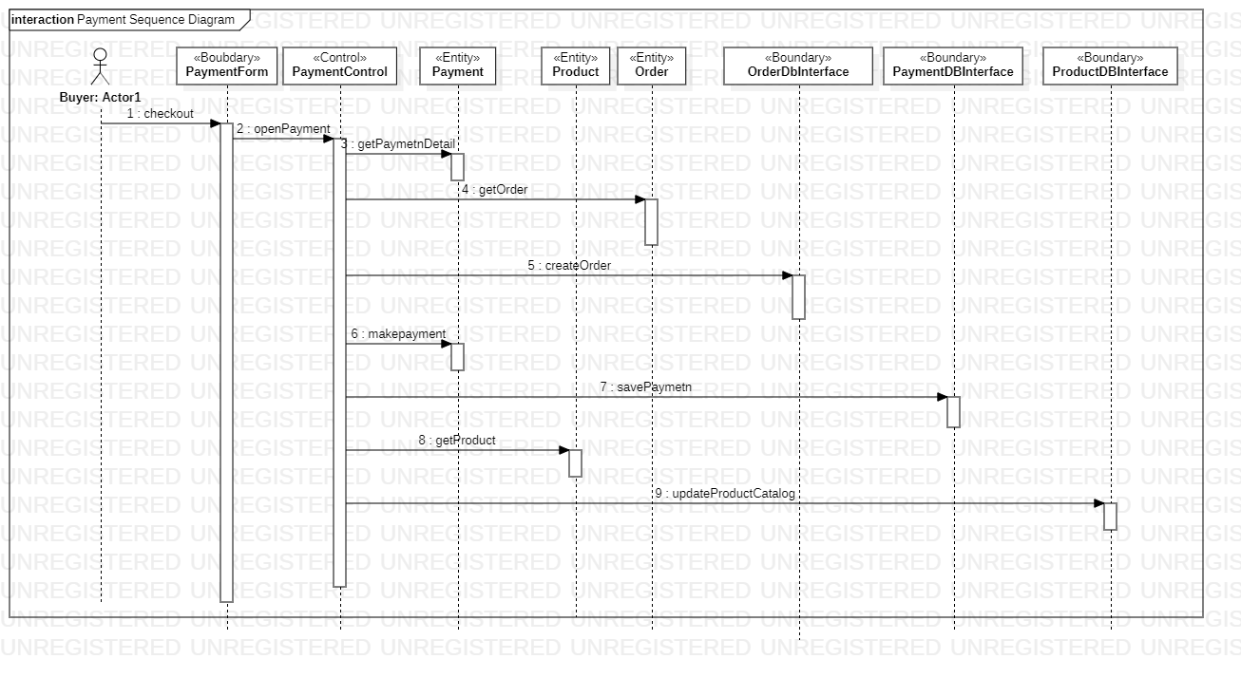

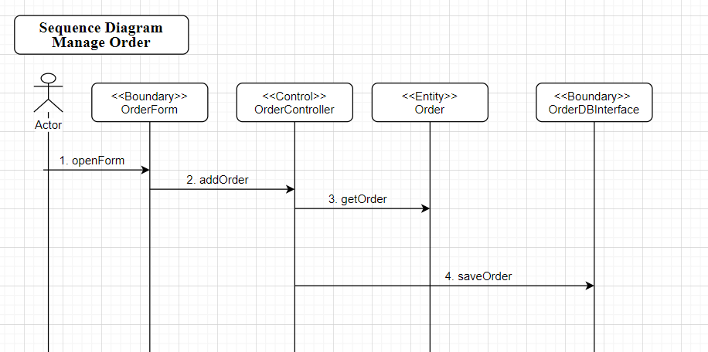

# Collaboration diagrams and vopc (view of participating class)

